 | 7.1.39 Editors - 3D Viewport - Header - Hair Curve - Edit mode – Control Point menu
Table of content
Edit mode – Control Points menu 1
Extrude Curve and Move 1

Edit mode – Control Points menu
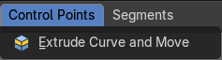

Extrude Curve and Move
Extrudes the selected hair curve points, and moves it.

